How to update intranet page with the EORTC macro

_______________________________________________________________________

1. Create a list of all SAS macro of the directory k:/SAS/EORTC macros
   1. Open Command Prompt and go to the K:/SAS/EORTC macro. Then type dir =>a list of all the macro of this directory will appear.
   2. 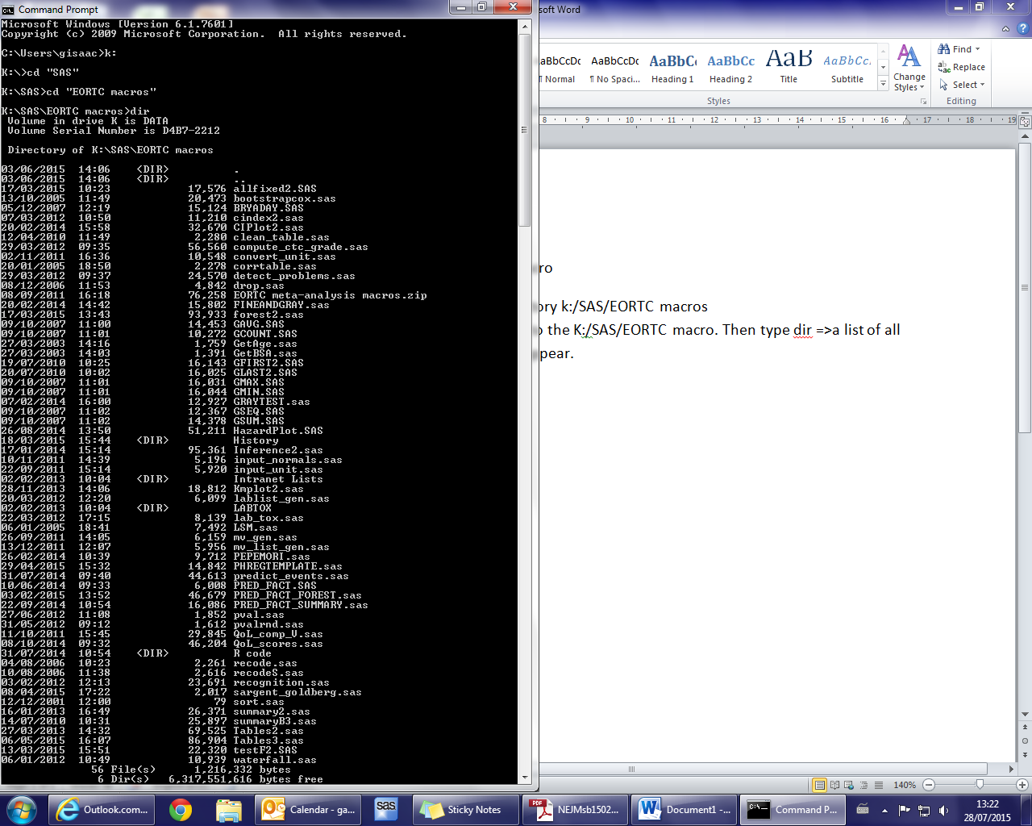Right click> select all>Enter
   3. Copy-paste in note pad
2. Go to K:\SAS\EORTC macros\Intranet Lists\Data and create a copy of the file ListMACROS.csv

Open it and Copy-paste all the name of macros(from AllFixed to Waterfall) from the notePad (.txt) to the csv file. Copy everything in the column A and delete the previous content of the columns B C D.

* Delete manually all the fields with <DIR> and with extension .zip
* 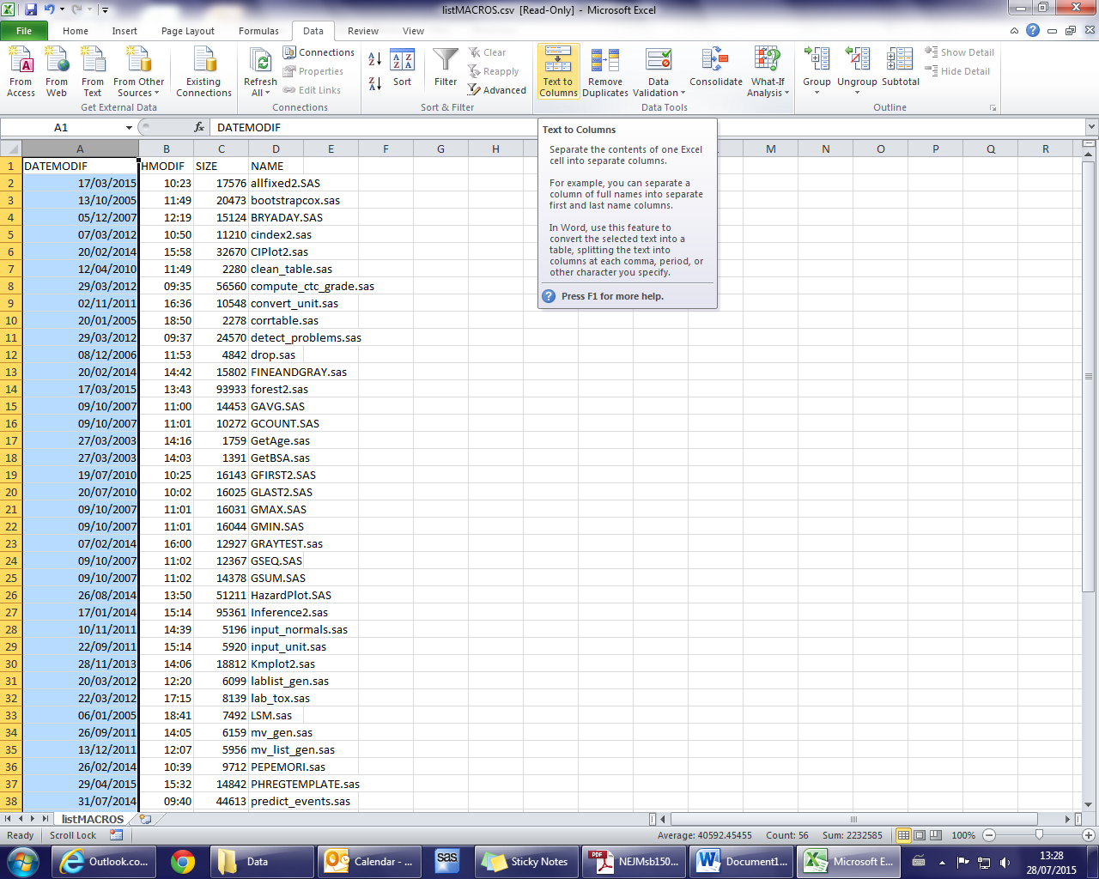Select the column A and click on Data > Text to columns
* 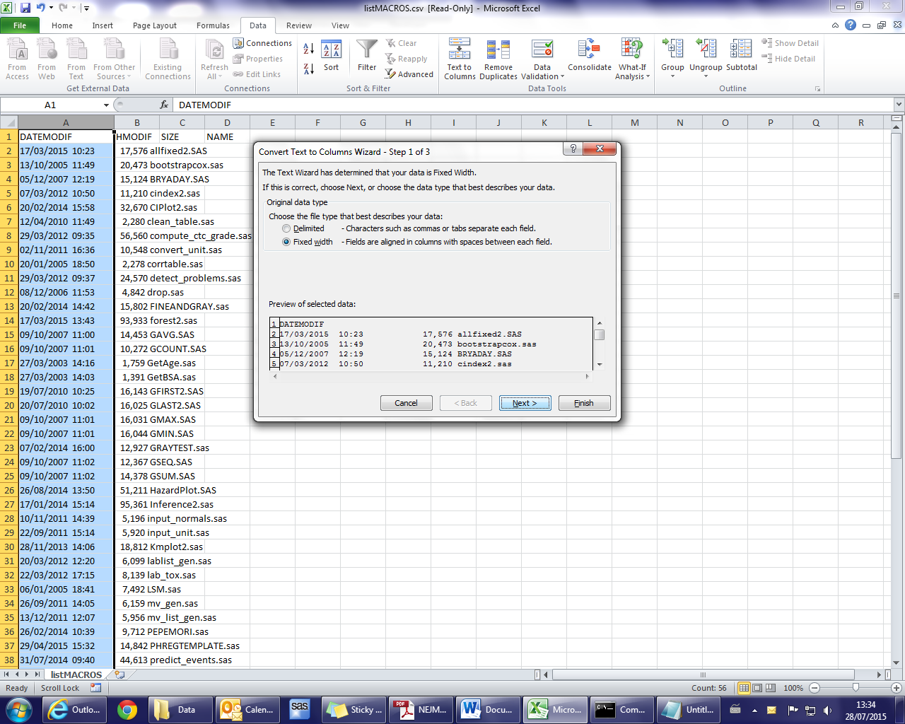Select “Fixed width” and click on NEXT and then FINISH. Rename the columns.

Don’t forget to change column C to numbers without coma. Save and close.

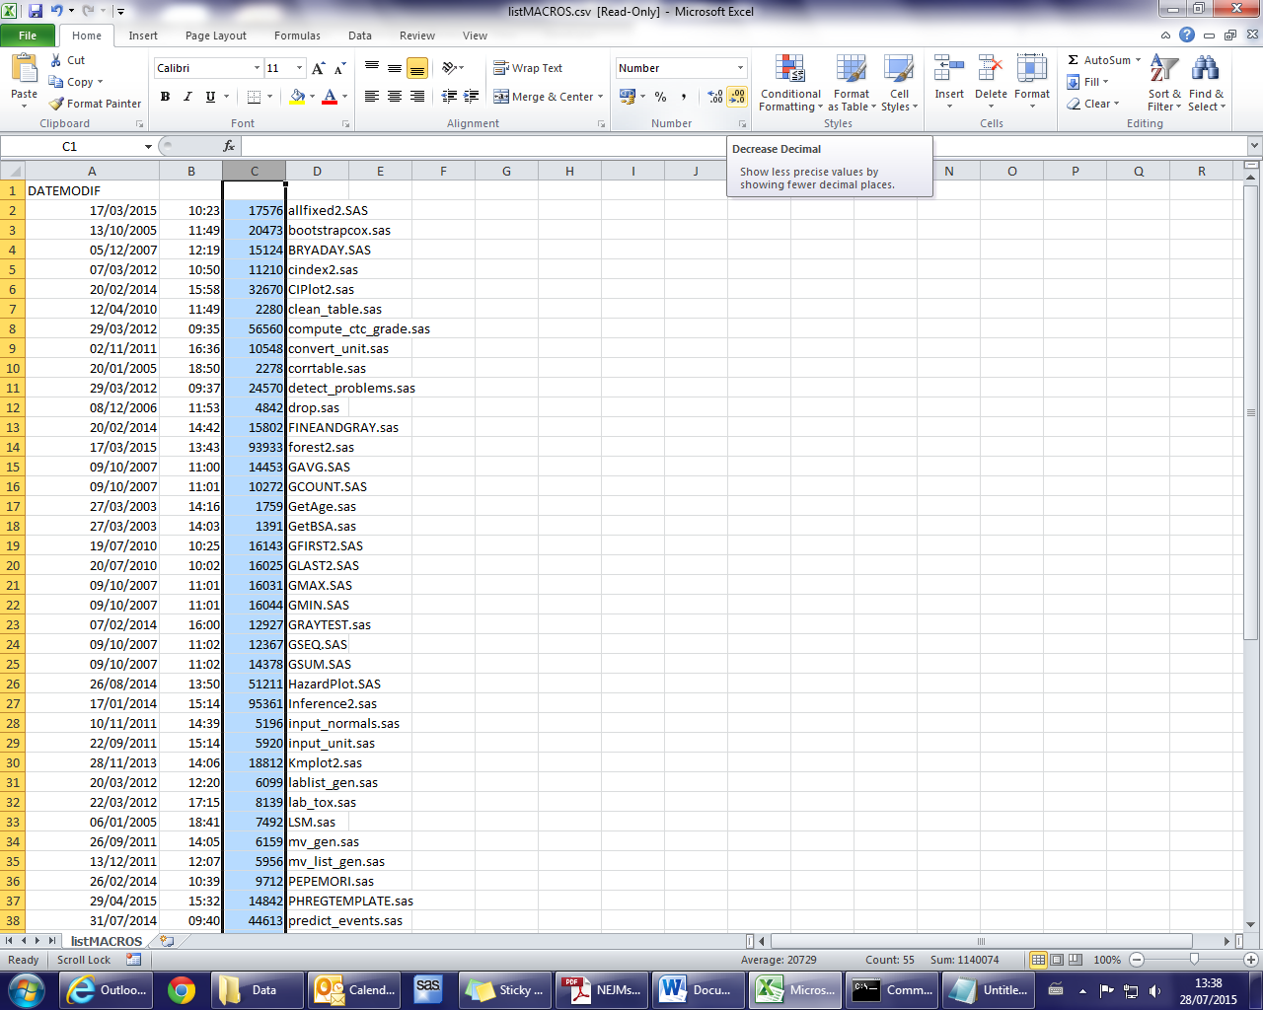

1. Go to K:\SAS\EORTC macros\Intranet Lists\Programs

* Create a copy of the program macrolistJR.sas (keep track of histoty) and modify thos code by adding the new EORTC macro(s)
* Open it and add the new macro via this block of code in the data step data testMod

if MACRO1="TABLES3" then do;

origdate=**'17APR2015'd**;

type="R";

desc_ln="This version let the user to compute the percentages including or excluding all missing values in the TOTAL";

desc_sh="Tables for study reports (% on column, row or Grand total)";

BasedOn="TABLES2.sas";

ADD="LC ";ADD1="KM "; ADD2="JRA";

end;

Add valid=Y if needed and the author:

if MACRO1 in ("ALLFIXED2" "ALLFIXEDB2" "CLEAN_TABLE" "FOREST2" "FORESTB2"

"FPLABELS" "GAVG" "GCOUNT" "GETAGE" "GETBSA" "GFIRST" "GLAST" "GFIRST2" "GLAST2" "GMAX" "GMIN"

"GSEQ" "GSUM" "INFERENCE" "KMPLOT2" "MEDIANNP" "MEDIANR" "PCTY2" "PVALRND"

"PVAL" "QOL_COMP_F" "RECODES" "RECODE" "SORT" "SUMMARY2" "SUMMARYB3"

"TABLES2" "TESTF2" "BRYADAY" "CIPLOT2" "QOL_COMP_V" "CINDEX2" "INPUT_UNIT"

"MV_GEN" "CONVERT_UNIT" "INPUT_NORMALS" "MV_LIST_GEN"

"RECOGNITION" "LABLIST_GEN" "COMPUTE_CTC_GRADE" "DETECT_PROBLEMS" "LAB_TOX" "WATERFALL" "GRAYTEST"

"PEPEMORI" "FINEANDGRAY" "HAZARDPLOT" "INFERENCE2" "PHREGTEMPLATE" "PRED_FACT"

"PRED_FACT_SUMMARY" "PRED_FACT_FOREST" "PREDICT_EVENTS" "TABLES3" "LAB_TOX") then valid='Y';

if MACRO1 in ("ALLFIXED2" "ALLFIXEDB2" "CLEAN_TABLE" "DROP" "FOREST2" "FORESTB2"

"GAVG" "GCOUNT" "GETAGE" "GETBSA" "GFIRST" "GLAST" "GMAX" "GMIN"

"GSEQ" "GSUM" "INFERENCE" "KMPLOT2" "PCTY2" "GFIRST2" "GLAST2"

"PCTY2" "PVAL" "PVALRND" "QOL_COMP_F" "RECODES" "RECODE" "SUMMARY2" "SUMMARYB3"

"TABLES2" "TESTF2" "CIPLOT2" "CINDEX2" "INFERENCE2" "PHREGTEMPLATE"

) then add='JRA';

* Add the new macro in the data ML.macrolist2014 (Documentation=Link)
* In data Processed, add a link to the word document

Ex: if macro1="TABLES3" then

documentation="<A href='\\elvis\Pccommon\UNIT\Stat\7. SAS and R\SAS Macros Documentation\TABLE\TABLES3 Documentation 1.0.doc'>link1</A> <A href='\\elvis\Pccommon\UNIT\Stat\7. SAS and R\SAS Macros Documentation\TABLE\TABLES3 macro.pptx'>link2</A>";

WARNING: Before running the program, save the previous output from the output directory to “previous”.

1. Copy-paste the three output files:
   1. CurrentMacros.htm
   2. CurrentMacrosByCategory.htm
   3. PastMacros.htm

From the server K:\SAS\EORTC macros\Intranet Lists\Output TO

The server Z:\sas\MacroLists

1. In the output repertory, modify the date of last update through the file MacroLists.htm by editing it in the txt file .

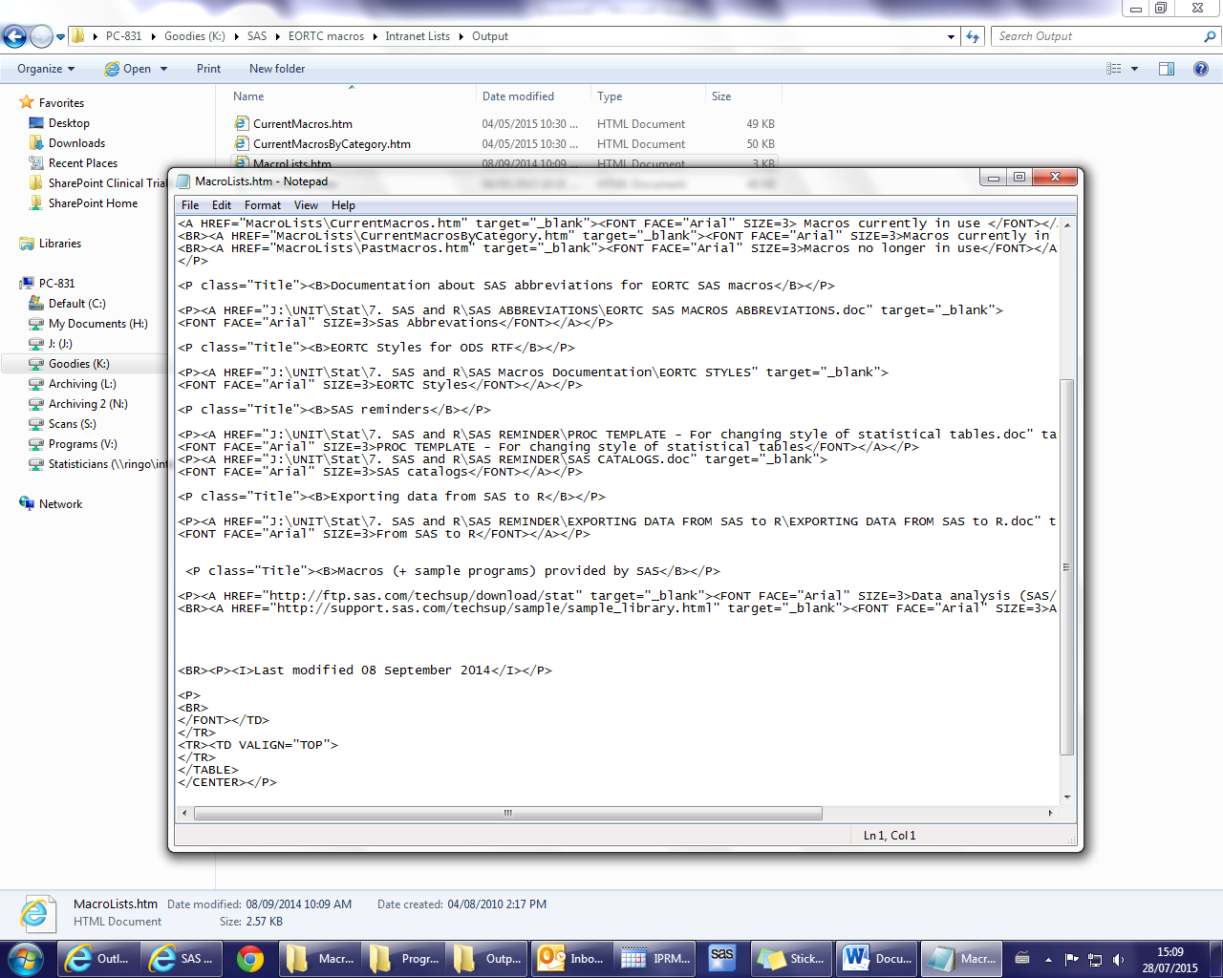

1. Save and copy this code in the Z:/ server

Z:\sas (NOT in the folder MacroLists)